Calculations – the process of how the answer was determined is needed. An answer without showing the steps will not earn points. The method can be from Excel or an RStudio output. It may also be a screenshot from an Internet calculator.

4-1: TWO SAMPLE MEANS T-TEST
Read & Understand Before Responding
- Lane (2013) Ch. 7 Difference between Two Means (Independent Groups)
Learning Objectives
- State the assumptions for testing the difference between two means
- Estimate the population variance assuming homogeneity of variance
- Compute the standard error of the difference between means
- Compute t and p for the difference between means
- Format data for computer analysis
Internet Sources
- Difference Two Independent Means (9:00): Difference Two Independent Means
- Normal Distribution Calculator: Normal Distribution Calculator
- t-Distribution Calculator (p-value): t-Distribution Calculator
- GraphPad. (2017) t-Test Calculator. t-Test Calculator

Check Your Understanding
- The graphs show a violation of the assumption of__. Select all that apply.
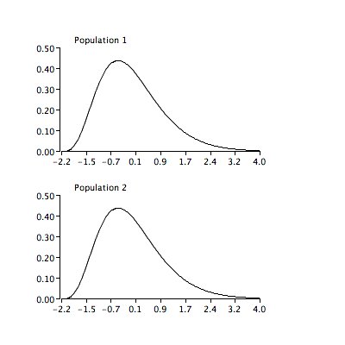
- normality
- homogeneity of variance

- The graphs show a violation of the assumption of__. Select all that apply.
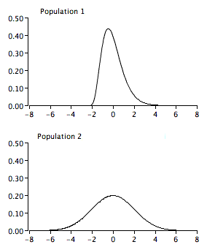
- normality
- homogeneity of variance
- The graphs show a violation of the assumption of__. Select all that apply.
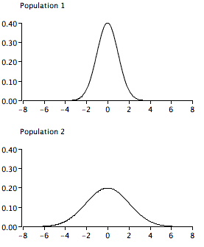
- normality
- homogeneity of variance
- In the formula for t, the "statistic" is

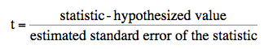
- the null hypothesis.
- the mean of all numbers.
- the difference between sample means.
- the significance level.

- In the formula for t, the "hypothesized value" is

- what you expect the t to be.
- the difference between population means.
- the significance level.

- If the null hypothesis is that two population means are equal, then the hypothesized value is
- 0.
- the population mean.

- The denominator in the t test formula is
- the estimated standard error of the mean.
- the estimated standard error of the difference between means.
- MSE/2

- If there are four scores per group and the t value is 2.34, what are the degrees of freedom, and the p value for a two-tailed test (to 3 decimal places)?
Note: Use the t-Distribution Calculator.
df = __
p-value = __

- What is the test statistic t for an independent-groups t test for these data? (to 3 decimal places)
Note. Use the Unpaired t-test calculator.
G1 | G2
61 | 34
49 | 46
51 | 44
45 | 48
56 | 25
44 | 38
67 | 47
65 | 46
t = __

- Scenario. Chicken Diet and Weight
Chicken farming is a multi-billion-dollar industry, and any methods that increase the growth rate of young chicks can reduce consumer costs while increasing company profits, possibly by millions of dollars.
An experiment was conducted to measure and compare the effectiveness of various feed supplements on the growth rate of chickens. Newly hatched chicks were randomly allocated into six groups, and each group was given a different feed supplement. Below are some summary statistics from this data set along with box plots showing the distribution of weights by feed type R Documentation (n.d.).
RQ: Is there a difference in average chicken weight based on diet?

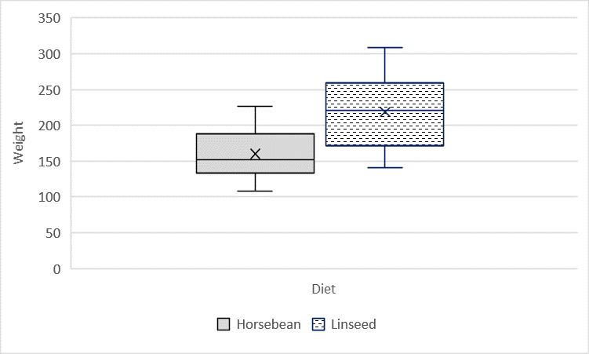 | 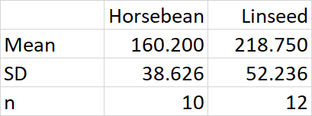

- Describe the distributions of weights of chickens that were fed linseed and horsebean regarding visual normality.

- Do these data provide strong evidence that the average weights of chickens that were fed linseed and horsebean are different at a 95% confidence level?
R:
horsebean <- c(179, 160, 136, 227, 217, 168, 108, 124, 143, 140)
linseed <- c(309, 229, 181, 141, 260, 203, 148, 169, 213, 257, 244, 271)
t.test (horsebean, linseed, var.equal = TRUE)
Excel: Use dataset X4_1_chickwt.xlsx

Step 1 Specify the null and alternate hypothesis (use symbols)
Step 2 Specify Alpha
Step 3 Calculate the Test Statistics and P-value
Step 4 Make a Decision
Step 5 State the Findings

- Would your Decision (Step 4) change if a 99% confidence level was used?

4-2: ALL PAIRWISE COMPARISONS AMONG MEANS
Read & Understand Before Responding
- Lane (2013) Ch. 7 Pairwise Comparisons Among Means
Learning Objectives
- Define pairwise comparison
- Describe the problem with doing t tests among all pairs of means
- Explain why the Tukey test should not necessarily be considered a follow-up test
Note. Nearly all textbooks introduce ANOVA then use Tukey HSD if Ho is rejected.
This concept will make more sense with hands-on experience.
Internet Sources
- Pairwise Comparisons Among Means (6:38): Pairwise Comparison Among Means
- Studentized Range Calculator: Studentized Range Calculator

Check Your Understanding
- You have an experiment with four groups. The problem with comparing each mean with each other mean using a Student's t test is:
- If you make several comparisons, you have an increased chance of a Type I error.
- The t test assumes normality, which does not occur with more than two groups.
- The assumption of independence is violated.

- A pairwise comparison is
- a comparison of two pieces of fruit.
- a comparison of two means.
- a comparison of two variances.

- Assume that you do an experiment with eight groups and the population means for all eight are equal. If you make all pairwise comparisons among the means using the 0.05 level, the chance that 1 or more comparisons will be significant is about:
- 0.05
- 0.10
- 0.20
- 0.50

4-3: ANALYSIS OF VARIANCE
Read & Understand Before Responding
- Lane (2013) Ch. 15 Analysis of Variance; Analysis of Variance Designs
Learning Objectives
- What null hypothesis is tested by ANOVA
- Describe the uses of ANOVA
- Explain why the Tukey test should not necessarily be considered a follow-up test
Note. Nearly all textbooks introduce ANOVA then use Tukey HSD if Ho is rejected.
- Be able to identify the factors and levels of each factor from a description of an experiment
- Determine whether a factor is a between-subjects or a within-subjects factor
- Define factorial design
- State the assumptions of a one-way ANOVA
- State the relationship between the t and F distributions
Internet Sources
- ANOVA Designs (3:37): Analysis of Variance Designs
- One Factor ANOVA (18:37) One Factor ANOVA
- Lowry (2017) VassarStats ANOVA Internet Calculator: ANOVA Internet Calculator

Check Your Understanding
- The omnibus null hypothesis when performing an analysis of variance is that there are differences between group means; however, no prediction is made concerning where the differences lie.
- True
- False
- Unlike t tests, an ANOVA may be used to test for differences among more than two groups.
- True
- False

- It is valid to do the Tukey HSD test without first finding a significant effect with an ANOVA.
- True
- False

Check Your Understanding
- Fifty subjects are each tested in both a control condition and an experimental condition. This test is an example of a:
- between-subjects design
- within-subjects design

- The times it took each of 20 subjects to name a set of colored squares and to read a set of color names were recorded. This test is an example of a:
- between-subjects design
- within-subjects design

- Subjects are randomly assigned to either a drug condition or a placebo condition. This test is an example of a:
- between-subjects design
- within-subjects design

- In a Gender (2) x Treatment (6) factorial between-subjects design, the total number of separate groups is
Total number: ___

Check Your Understanding
- Unlike t tests, an ANOVA uses both differences between group means and differences within groups to determine whether or not the differences are significant.
- True
- False

- The "Smiles and Leniency" study uses a between-subjects design. The four types of smiles (false, felt, miserable, and neutral) are the four levels of one factor.
- True
- False

- Which best describes the assumption of homogeneity of variance?
- The populations are both normally distributed to the same degree.
- The between and within population variances are approximately the same.
- The variances in the populations are equal.

- When performing a one-factor ANOVA (between-subjects), it is important that each subject only provide a single value. If a subject were to provide more than one value, the independence of each value would be lost, and the test provided by an ANOVA would not be valid.
- True
- False

- ANOVA and Tukey HSD Hypothesis Test
These test scores are from three independent class groups. Perform a one-way ANOVA. Calculate Tukey HSD to determine (if any) groups are different?
RQ: Is there a difference in test scores based on class group?
R:
# One-Way ANOVA with Tukey HSD
# Import X4_3_Groups.csv
data <- X4_3_Groups $ Data
group <- X4_3_Groups $ Group
group3 <- aov (data ~ group, data=X4_3_Groups)
summary (group3) # display ANOVA table
TukeyHSD (group3, conf.level = 0.95) # identify pairs not equal
Excel: Use dataset X4_3_Groups.xlsx
G1 | G2 | G3
59 | 35 | 43
41 | 46 | 44
52 | 34 | 48
41 | 39 | 70
35 | 46 | 57
59 | 32 | 58
65 | 39 | 67
62 | 38 | 43
Step 1 Specify the null and alternate hypothesis (use symbols)
Step 2 Specify Alpha
Step 3 Calculate the Test Statistics and P-value
Step 4 Make a Decision
Step 5 State the Findings

4-4: CHI-SQUARE
Read & Understand Before Responding
- Lane (2013) Ch. 17 Chi Square; Contingency Tables
Learning Objectives
- Describe how the shape of the Chi Square distribution changes as its degrees of freedom increase
- State the null hypothesis tested concerning contingency tables
- Compute expected cell frequencies
- Compute Chi Square and degrees of freedom (df)
Internet Sources
- Chi Square Distribution (2:57): Chi Square Distribution
Note. Lost voice around 7:00
- Contingency Tables (5:36) Contingency Tables
- Lowry (2017) VassarStats ANOVA Internet Calculator: ANOVA Internet Calculator

Check Your Understanding
- Which Chi Square distribution looks the most like a normal distribution?
- A Chi Square distribution with 0 df
- A Chi Square distribution with 1 df
- A Chi Square distribution with 2 df
- A Chi Square distribution with 10 df

Check Your Understanding
- Suppose an experimenter asked a group of 60 participants whether they could be scared by a movie. Then the experimenter had the participants watch a scary movie. After the movie, the experimenter again asked them if they could be scared by a movie. The experimenter's data appear in the table below. Can this experimenter use the Chi Square test to see whether watching the scary movie made more people say that they could be scared by movies?

 | Scared | Not Scared
Before | 25 | 36
After | 37 | 23
- Yes
- No

- A student is interested in whether there is a relationship between gender and major at her college. She randomly sampled some men and women on campus and asked them if their major was part of the natural sciences (NS), social sciences (SS), or humanities (H). Her results appear in the table below.

Gender | NS | SS | H | Total
Women | 10 | 14 | 10 | 34
Men | 11 | 8 | 4 | 23
Total | 21 | 22 | 14 | 57

- What would be the expected frequency of women in social sciences based on this table? Fill in the table.
Gender | NS | SS | H | Total
Women | /// |  | /// | 34

- Conduct a Chi Square hypothesis test to determine if there is a relationship between gender and major.

RQ: Is there a relationship between gender and major?
Step 1 Specify the null and alternate hypothesis (no symbols for Chi-Square)
Step 2 Specify Alpha
Step 3 Calculate the Test Statistics and P-value
Step 4 Make a Decision
Step 5 State the Findings

References
GraphPad. (2017). T test calculator. Retrieved from https://www.graphpad.com/quickcalcs/ttest1/?Format=C
Lane, D. M. (2013). Online statistics education: A multimedia course of study. Retrieved from http://onlinestatbook.com/2/
Lowry, R. (2017). One-way analysis of variance for independent or correlated samples. Retrieved from http://vassarstats.net/anova1u.html
R Documentation (n.d.). Chicken weights by feed type from the datasets package in R. Retrieved from http://stat.ethz.ch/R-manual/R-patched/library/datasets/html/chickwts.html

